**Supplementary Information S6.**

Observed distributions (left column) and predicted presences for constant dispersal (centre column) and GDK models (right column) for each pest species. Presences are shown in green.

Real Data Constant GDK

*Wood-boring Pests*

../../../scripts/1fitting.pdf../../../scripts/2fitting.pdf

../../../scripts/4fitting.pdf ../../../scripts/5fitting.pdf../../../scripts/6fitting.pdf ../../../scripts/7fitting.pdf ../../../scripts/8fitting.pdf ../../../scripts/9fitting.pdf ../../../scripts/10fitting.pdf

*Defoliating Pests*

../../../scripts/11fitting.pdf ../../../scripts/12fitting.pdf

../../../scripts/13fitting.pdf../../../scripts/14fitting.pdf ../../../scripts/15fitting.pdf../../../scripts/16fitting.pdf../../../scripts/17fitting.pdf

../../../scripts/18fitting.pdf../../../scripts/19fitting.pdf../../../scripts/20fitting.pdf ../../../scripts/21fitting.pdf../../../scripts/51fitting.pdf

../../../scripts/22fitting.pdf../../../scripts/23fitting.pdf ../../../scripts/24fitting.pdf../../../scripts/25fitting.pdf ../../../scripts/26fitting.pdf ../../../scripts/27fitting.pdf ../../../scripts/28fitting.pdf ../../../scripts/29fitting.pdf ../../../scripts/30fitting.pdf ../../../scripts/31fitting.pdf ../../../scripts/32fitting.pdf

*Tree Pathogens*

../../../scripts/33fitting.pdf../../../scripts/34fitting.pdf../../../scripts/35fitting.pdf ../../../scripts/36fitting.pdf../../../scripts/37fitting.pdf../../../scripts/38fitting.pdf../../../scripts/39fitting.pdf ../../../scripts/40fitting.pdf../../../scripts/41fitting.pdf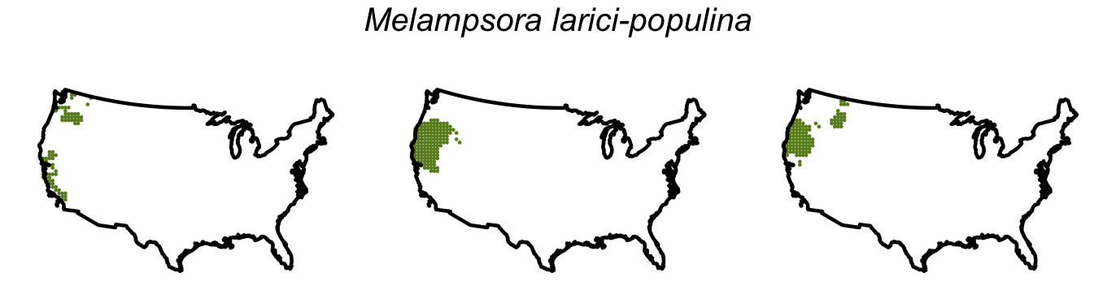 ../../../scripts/42fitting.pdf../../../scripts/43fitting.pdf../../../scripts/44fitting.pdf

../../../scripts/45fitting.pdf../../../scripts/46fitting.pdf*Sap-Feeding Pests*

../../../scripts/47fitting.pdf../../../scripts/48fitting.pdf../../../scripts/49fitting.pdf../../../scripts/50fitting.pdf ../../../scripts/52fitting.pdf../../../scripts/53fitting.pdf ../../../scripts/54fitting.pdf../../../scripts/55fitting.pdf ../../../scripts/56fitting.pdf../../../scripts/57fitting.pdf../../../scripts/58fitting.pdf../../../scripts/59fitting.pdf ../../../scripts/60fitting.pdf../../../scripts/61fitting.pdf../../../scripts/62fitting.pdf../../../scripts/63fitting.pdf../../../scripts/64fitting.pdf